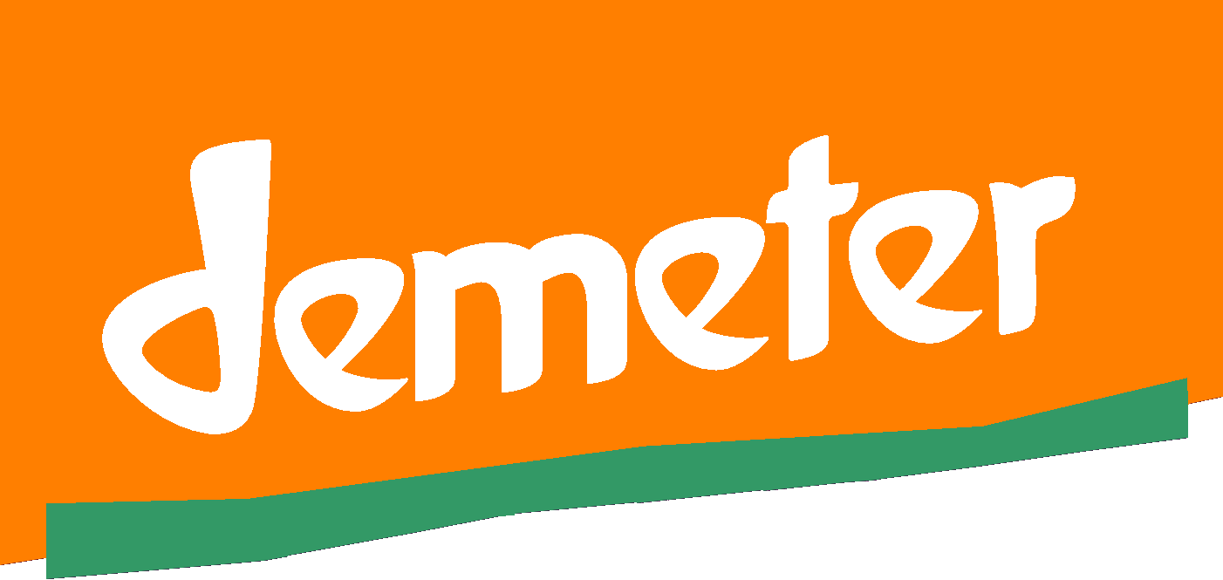
The Winery Report Template
For Winery of
Demeter Certified Vineyard
Version Nov 2020
Version Aug 2019

This document is a list of headings you use to prepare a description of the winery for review and audit. Keep an electronic copy of your description so it can easily be revised as necessary.

Procedure for this report:
Please use the headings to organise your report. Supply details typed on separate sheets. You will need to refer to the Demeter Wine section in the International Demeter Biodynamic Standard (IDBS), available from https://www.demeter.net/certification/standards They are Section 7.12 of these standards.

In Section 3. Fundamental Requirements of the International Demeter Biodynamic Standard there are some general requirements that apply to all products. You should check this section too.

What we do with your report:

We use it as the basis for an audit of your winery. If your winery complies with the Demeter Standards, we will tell you. At that stage you can apply to have individual wines certified if you wish. Ask us for the Wine Batch Form to do this.

- Products | List wines and any other products made in the winery and briefly describe them if not self-explanatory. (Where any non-wine products are made, you should use the Demeter New Zealand general processing template for those to ensure that any non-wine requirements are not overlooked.)
- Legal Requirements | - What Health Authority, resource consents or MPI etc approvals have been gained? Give licence or certificate numbers or dates. Please supply copies of relevant certificates.  - Are they up to date?
- Building(s) and location | - Briefly describe buildings. Is there any possibility of adverse effects from neighbours?  - Supply location map of processing buildings.  - Supply sketch plans of processing buildings with layout of equipment.  - Does cleaning of buildings and pest management comply with International Demeter Biodynamic Standard Section 6?
- Ingredients | - State the source of the grapes and the arrangements for weighing on arrival. (Inward weight should be tallied with expected yields from vineyard.) Brought-in grapes will need documentary proof of certification status to be supplied each time.  - List consumables (additives and processing aids) you will use in wine making and state their sources. See footnote #.  - Are all consumables in the permitted list of the wine section of the International Demeter Biodynamic Standard (Section 8.12.)?  - Note any consumables you will use that have specific restrictions in the standards (Section 8.12.) e.g. there are restrictions on uses of yeast and bentonite.  - Describe water quality and source. Provide test results if available.  # Footnote: The standards permit some non-Demeter ingredients if Demeter ones are not available (IDBS Section 3.1.2.) e.g. organic sugar may be used if Demeter sugar is not available. If you intend to use a non-Demeter ingredient because you believe a Demeter one is not available, you should provide information to justify that belief.
- Transport | - How are grapes transported from the vineyard?  - How is integrity maintained during transport? State vehicle cleaning, handling methods and prevention of cross contamination (e.g. by non-Demeter fruit), where relevant.

- Processing | - What machinery and equipment – tanks (what material are they made from), pumps (type of pump) - do you use  - Is all equipment permitted by the standards?  - What cleaning agents and methods are used for the machinery? Are they all within the standards?  - Is there any non-Demeter processing carried out? If so:  - How is equipment cleaned afterwards?  - How is cross contamination (mixing of Demeter with non-Demeter) avoided?  - Does this processing use any procedures listed in the International Demeter Biodynamic Standard (Section 4.2.2.)?  - Does this processing use any aids not in the Demeter permitted list?
- Storage | - How is unprocessed fruit stored?  - How do you ensure that stored fruit remains free from contamination (e.g. by vermin or bugs)?  - What control is used for insects, fungi or rodents?  - How is fruit and bulk wine moved to and from storage?  - How is fruit or bulk wine in storage labelled?
- Bottling | - Where is bottling done?  - How does the wine get there?  - What bottles and closures are used? (State exact types e.g. “High Density Polyethylene (HDPE)”, not “plastic”.)  - Are bottles, closures and other packaging compliant with International Demeter Biodynamic Standard?  - Supply copies of labels (labels with Demeter on them or implied must be approved). See Demeter New Zealand Production Standards (Section 3.14.) and International Demeter Biodynamic Standard (Section 5.).  - How is sulphur dioxide tested for?
- Personnel and Contracts | - State name, address telephone number of any subcontractor used, and name of responsible person.  - Describe contractual arrangements with subcontractors.  - Supply copies of the instructions you give each contractor.  - How do the arrangements ensure contractors do not change any details of systems you describe to us?

